Azure Function App

When create Function App from Azure Portal, you need to specify the Storage Account Connection String

* + - * Storage Account Connection String can be found here:

* There is a project template called “Azure Functions”

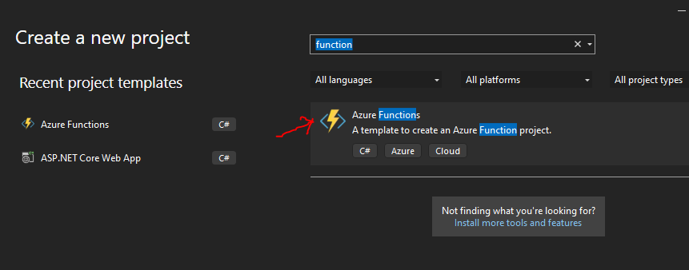

You can pick Authentication Level

* Azure Function usually has a triger (by HTTP Request or Message Queue etc.)

Or

* Publish through Visual Studio
* Create Azure Function App first

* Then use Publish to Azure directly

* Publish through Power Shell
* Go to Function App’ s bin folder where it contains the .dll and host.json file

* Use CICD pipeline to deploy

CI (Build) YAML file

|  |
| --- |
| pool:    name: 'Default'  steps:  - script: |      dotnet restore      dotnet build --configuration Release  - task: DotNetCoreCLI@2    inputs:      command: publish      arguments: '--configuration Release --output publish_output'      projects: '*.csproj'      publishWebProjects: false      modifyOutputPath: false      zipAfterPublish: false  - task: ArchiveFiles@2    displayName: "Archive files"    inputs:      rootFolderOrFile: "$(System.DefaultWorkingDirectory)/publish_output"      includeRootFolder: false      archiveFile: "$(System.DefaultWorkingDirectory)/build$(Build.BuildId).zip"  - task: PublishBuildArtifacts@1    inputs:      PathtoPublish: '$(System.DefaultWorkingDirectory)/build$(Build.BuildId).zip'      artifactName: 'drop' |